HW Design for New Lighting System

Yong Gang, Gu(Forrest)
Hong Hui, Tan
Revision 0.2

May 1st , 2016

Rev. | Orig. of  Change | Date of Change | Description of Change
0.1 | Forrest | 3/1/2016 | First Version
0.2 | Forrest | 5/2/16
0.3
0.4

Introduction
This document describes HW design for Dali controller board.

System Architecture
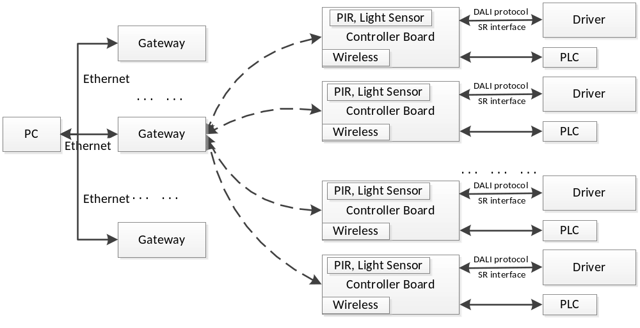
- Wireless
Now we choose Zigbee as wireless transfer solution, because till now only Zigbee has Mesh technique.
Nevertheless, we need to keep eye on Bluetooth protocol development and Wifi production update:
- Bluetooth group will add mesh protocol in Ver4.3 spec. in 2016;
- Rockchip announced ultra-low-power WIFI processor: RKI6000 in 2015
- Zigbee’s promotion to the market and application is not good during 2013 – 2015, compared with Bluetooth.
For 1 and 2 above, it will bring convenience to customer because most of them could use smartphone, plus application installed in the phone, to control the light.
- SR interface
SR interface follows Dali spec. Controller board needs to transfer signals to driver, and get power from SR interface.
- PIR/Light Sensor
PIR light sensor are used to detect:
If environment is dark, and there is person passing by the light area, the controller send command to driver to light on, or it will keep the light off.
- PLC
Controller board needs to support PLC, in case when Zigbee communication is blocked.
There are two types of PLC products considered.
One is PLC module which has UART interface, the module is embedded on controller board, so the overall size is small. The disadvantage is the supply.
The other is PLC modem with Ethernet interface. The PLC modem(电力猫) is certified product, and the supply is not concern, because there are lots of products which could be choose. Another advantage is the controller has Ethernet interface, so it can also be used as gateway. The disadvantage is:
- PLC modem size is relatively big, so need to consider the artistry in engineering installation.
- PLC communication need all nodes in “power line local area”, transformer can not be set between nodes.

HW architecture
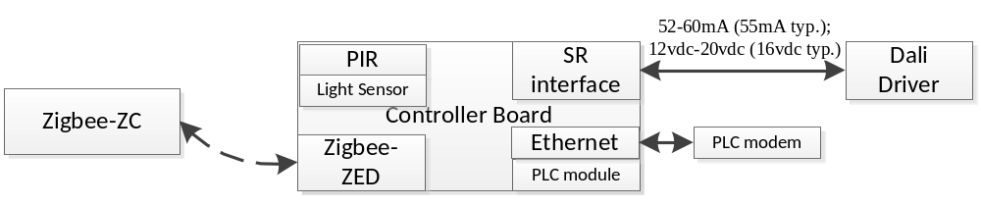

HW design
Based on SR spec. 1.0, the power from driver to Controller is 52mA*12v = 624mW at minimum. Considering when data transferred through DALI interface, the power will be smaller, we leave margin at 75%; the power needs to be converted to 3.3v for controller, the power convert ratio will be 75%. So the power limitation for Controller board is:
52mA*12v*75%*75%/3.3v=106mA
Based on the requirement above, make HW design shown below:
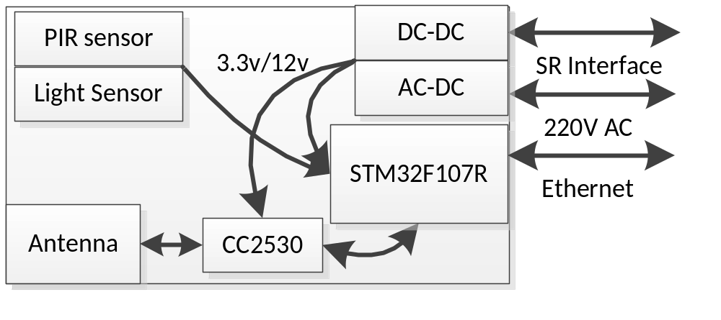
Choose STM32F107 as main MCU on controller board, including:
- Communicate with CC2530;
- Detect PIR sensor, Light sensor;
- Transfer through SR interface and Ethernet interface.
The reason to choose CC2530:
CC2530 has the mid cost and high performance, which meets the requirements.
CC2533 and CC2630 are the candidates if not CC2530.

 | CC2630 | CC2650 | CC2538 | CC2533 | CC2531 | CC2530
SubFamily | SimpleLink CC2x | SimpleLink CC2x | SimpleLink CC2x | SimpleLink CC2x | SimpleLink CC2x | SimpleLink CC2x
SubFamily | SimpleLink CC2x | SimpleLink CC2x | 无线 MCU | 无线 MCU | 无线 MCU | 无线 MCU
I2S | 0 | 1 | 0 | 0 | 0 | 0
Frequency (MHz ) | 48 | 48 | 24 | 24 | 24 | 24
Flash (KB) | 128 | 128 | Up to 512 | Up to 96 | Up to 256 | Up to 256
SRAM (kB ) | 20+2+8 | 20+2+8 | Up to 32 | Up to 6 | 8 | 8
I2C | 1 | 1 | 1 | 1 | 0 | 0
SPI | 2 | 2 | 2 | 1 | 1 | 1
UART | 1 | 1 | 2 | 1 | 1 | 1
ADC | 12-bit, 8 channel, 200 KSPS | 12-bit, 8 channel, 200 KSPS | 12-bit, 8 channel | N/A | 12-bit, 8 channel | 12-bit, 8 channel
Timers - 16-bit | 8 | 8 | 8 | 1 | 1 | 1
Timers - 32-bit | 4 | 4 | 4 | 0 | 0 | 0
Min VCC | 1.65 |  | 2 | 2 | 2 | 2
Max VCC | 3.8 |  | 3.6 | 3.6 | 3.6 | 3.6
Standby Power (LPM3-uA) | 1 | 1 | 0.4 | 0.4 | 0.4 | 0.4
Wakeup time from standby (us ) |  |  | 500 | 600 | 500 | 500
Additional Features | Ultra-low power Sensor Controller | Ultra-low power Sensor Controller | USB | N/A | USB | N/A
Additional Features | Capsense | Capsense
Additional Features | 1 uA RTC with data retention (RAM/CPU) | 1 uA RTC with data retention (RAM/CPU)
Additional Features | Over-the-air upgrade | Over-the-air upgrade
Operating Temperature Range (C ) | -40 to 85 | -40 to 85 |  | -40 to 125 | -40 to 125 | -40 to 125
Package Group | VQFN | VQFN | QFN | VQFN | VQFN | VQFN
Approx. Price (US$) | 2.65 | 1ku | 3.00 | 1ku | 3.40 | 1ku | 2.55 | 1ku | 3.20 | 1ku | 2.75 | 1ku
RF standard supported | ZigBee | Bluetooth Smart (Bluetooth low energy) | ZigBee | 2.4-GHz IEEE 802.15.4 | ZigBee | ZigBee
RF standard supported | 6LoWPAN | ZigBee | 6LoWPAN | ZigBee | 6LoWPAN | 6LoWPAN
RF standard supported | 802.15.4 MAC | ZigBee RF4CE | 802.15.4 MAC |  | 802.15.4 MAC | 802.15.4 MAC
RF standard supported |  | 6LoWPAN
RF standard supported |  | 802.15.4 MAC
Standard version | See software section of product page | See software section of product page | See software section of product page | See software section of product page | See software section of product page | See software section of product page
Data Rate (Max) (kbps ) | 250 | 1000 | 250 | 250 | 250 | 250

Power consumption calculation:
MAX232: 7mA
CC2530: 25mA
STM32F107R: 35mA
PIR/Light sensor: 5mA
The power margin is for other components is 34 mA.

Ethernet physical chip DP83848: 85mA
That means SR interface’s power can not support Ethernet transfer. When Ethernet is used, 220v power should be connected as power source.

Other components
Item | Part Number | Link
Infrared receiver | VS1838B,HS0038 | https://item.taobao.com/item.htm?spm=a230r.1.14.4.R8AJqJ&id=178521861&ns=1&abbucket=11#detail
Light sensor | Vishay TEMT6000  BH1750FVI-TR WSOF6  APDS-9008  AP3216C | https://item.taobao.com/item.htm?spm=a230r.1.14.1.oxSaqV&id=42248233846&ns=1&abbucket=11#detail  https://item.taobao.com/item.htm?spm=a230r.1.14.34.TOg8cZ&id=520304389592&ns=1&abbucket=11#detail  https://item.taobao.com/item.htm?spm=a230r.1.14.21.TOg8cZ&id=36663875191&ns=1&abbucket=11#detail  https://item.taobao.com/item.htm?spm=a230r.1.14.60.TOg8cZ&id=37168607844&ns=1&abbucket=11#detail
PIR | Module: HC-SR501;  PIR sensor:尼塞拉RE200BP  森霸光敏电阻控制  拓安达TAD-K616-12VDC | https://detail.tmall.com/item.htm?spm=a230r.1.14.6.NYiVOD&id=41292136749&cm_id=140105335569ed55e27b&abbucket=11  https://detail.tmall.com/item.htm?spm=a1z10.5-b.w4011-3080881932.92.ps9lH8&id=35078845756&rn=219e34c91e3b1564b15b8df1a4d613ac&abbucket=12
Zigbee | CC2530 module | https://item.taobao.com/item.htm?spm=a1z0k.7385993.1997994373.d4919385.zjgHai&id=16005566467&_u=6ditef0400
DALI | Optocoupler(光耦)：PC817C | https://detail.tmall.com/item.htm?id=44492313103&ali_refid=a3_420434_1006:1110788254:N:光耦:9a40314e938cad4d1d3a8a3ad4dcbd69&ali_trackid=1_9a40314e938cad4d1d3a8a3ad4dcbd69&spm=a230r.1.0.0.wDBYzw
PLC | Eastsoft: PLCS1650
Amp | NE5532 or SGM8272
RJ45 connector | HR911105A | https://item.taobao.com/item.htm?spm=a230r.1.14.10.ijOmyR&id=37681624200&ns=1&abbucket=11#detail
connector | 2EKG5.08 socket | https://item.taobao.com/item.htm?id=15725530241&ali_refid=a3_430008_1006:1103053562:N:插拔式接线端子:296e8464c1442b372599369ddcc43453&ali_trackid=1_296e8464c1442b372599369ddcc43453&spm=a230r.1.0.0.KM0WUT
power | AC-DC module  LNK302-306  离线式开关IC | https://item.taobao.com/item.htm?spm=a230r.1.14.15.j7jQ8q&id=38965413134&ns=1&abbucket=11#detail  https://detail.tmall.com/item.htm?spm=a230r.1.14.1.9M9sxm&id=520866913051&cm_id=140105335569ed55e27b&abbucket=11
Fuse | TRF250-400 250V 0.4A 400MA | https://item.taobao.com/item.htm?spm=a230r.1.14.187.3HyAve&id=527216523909&ns=1&abbucket=11#detail  https://detail.tmall.com/item.htm?spm=a1z10.5-b.w4011-9190505631.105.tVx1D0&id=21806487499&rn=d004d22c3d9be0af4c7c81489967d46f&abbucket=12  http://www.jdtfuse.com/
Inductor | 工字电感  贴片电感 | https://item.taobao.com/item.htm?spm=a230r.1.14.24.hsOuGT&id=17675736119&ns=1&abbucket=11#detail  https://item.taobao.com/item.htm?spm=a230r.1.14.41.hsOuGT&id=521167796980&ns=1&abbucket=11#detail
Crystal | 25M，  32.768K | https://detail.tmall.com/item.htm?spm=a230r.1.14.1.7cE1T4&id=41210299154&cm_id=140105335569ed55e27b&abbucket=11  https://detail.tmall.com/item.htm?spm=a230r.1.14.6.86VSjZ&id=13522795558&cm_id=140105335569ed55e27b&abbucket=11
Switch | 按键开关  轻触开关 | https://detail.tmall.com/item.htm?spm=a1z10.5-b.w4011-3079908263.53.SvPGDW&id=14571064309&rn=aa9b689bcc27c029809e1e247c138f47&abbucket=12
Diode | IN4148 | https://detail.tmall.com/item.htm?spm=a1z10.5-b.w4011-3079908263.83.W6NwMK&id=14037506268&rn=d0f84e3a9ff31d7b54a6d3716ec8e8a0&abbucket=12

HW Price list
No. | Function | Chip | Price(RMB)
1 | Power | MP2359*2 | 1.6
2 |  | CC2530 module | 20
3 | Zigbee | CC2530 chip | 9
4 | MCU | STM32F107R | 12
5 |  | connector | 3-5
6 | Light Sensor | APDS-9008(Avago) | 4.8
 |  | TEMT6000X01(Vishay) | 3.2
 |  | AP3216C (Liteon) | 1.5
 |  | BH1750FVI(ROHM) | 3.5
7 | PIR | HC-SR501 | 3.6
8 |  | PCB board | 7-10
9 |  | SMA | 7-11(?)
10 |  | Convert circuit | 2
 | Power(ACDC) | LNK306GN LNK306 贴片SOP7 AC-DC转换芯片 | 3.5
 | Total |  | 55
 | Optional PLC | PLC1650
 | Optional Ethernet | DP83848CVV | 8

